Introduction Link : [Introduction to Cycloidal Curves (Cycloid, Epicycloid & Hypocycloid)](https://youtu.be/EHMZkYhOX0E)

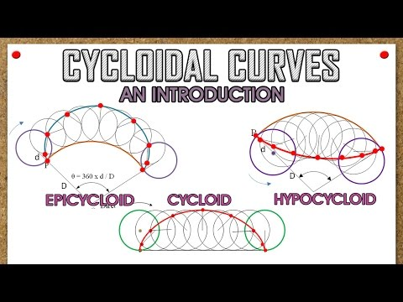

1. Steps for construction of cycloid : <https://www.youtube.com/watch?v=R39tO77LPCY>
2. Steps for construction of epicycloid : <https://www.youtube.com/watch?v=Ola-dgVf7nE>
3. Steps for hypocycloid : <https://www.youtube.com/watch?v=hYSxjdHE550&t=33s>